PROPER CATCHING STANCES
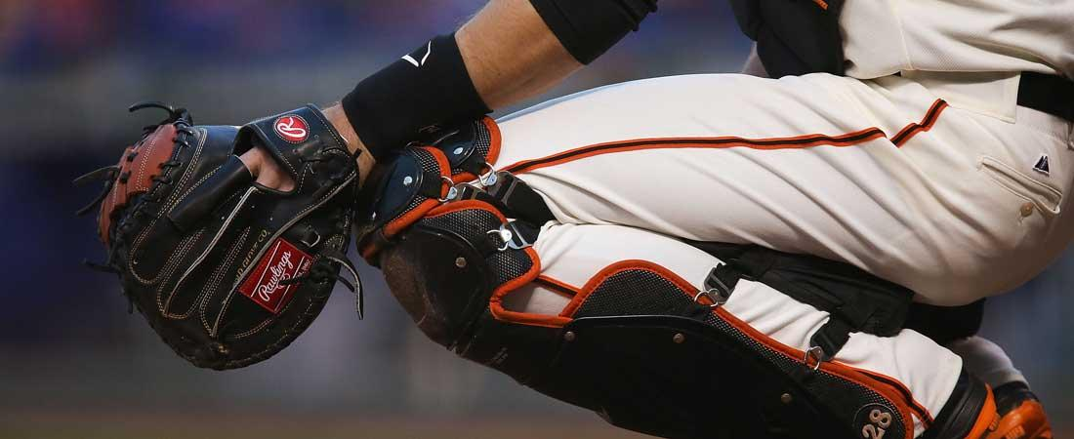
As with every position in baseball, we want to start each play with a good foundation. The catcher's stance is the foundation from which everything happens off of. From here he will call the game, receive pitches and throw out runners. With each situation, the stance is altered in anticipation of the next play.
While each catcher is different, there are some fundamental touch points that every catcher can be mindful of. They are as follows:

SIGNAL STANCE
- Feet should be square to the pitcher about a foot apart.
- Body should split the plate in half.
- Left knee should point at shortstop position.
- Right knee should be closed enough so a runner on first base cannot see the signs.
- Glove should extend beyond left knee to guard against the third base coach.
- Throwing arm should rest in hip flexor crevice with elbow tucked in.
- Hand should be even with cup. Be aware not to give sign too high or too low.
- Catcher should check positioning of batter in the box and be aware of peeking.

RECEIVING STANCE
- After giving the sign, the catcher should shift into a comfortable but fundamentally sound receiving position.
- A quiet move to the proper location inside or outside should be at the right time so that the hitter cannot see it and runners on base cannot relay location.
- Feet should remain shoulder width apart with weight on the inside of the feet and toes turned slightly out.
- Glove arm should be slightly extended to give a good target.
- Glove positioning should be with fingers pointed to the sky. This will allow the elbow to remain tucked and give the pitcher an open glove target.
- Glove should be visible and not move until the pitcher releases the pitch.
- Position within the catcher's box will vary according to the hitter. Always stay as close to the hitter as possible without interfering.
- Bare hand should be behind right heel, behind the back or by the right groin.

STANCE WITH RUNNERS ON
- With runners on base or with two strikes on the hitter, a modified receiving stance becomes a more athletic throwing/blocking position.
- Feet should be shoulder width apart with weight on the balls of the feet.
- Knees should be inside the ankles with rear elevated in a ready position.
- Giving a good, open target is still necessary. Remember "fingers to the sky."
- Bare hand should be in a comfortable place behind the glove or by the right groin.

