# Comparing Head Impacts in Youth Tackle and Flag Football

A [CDC study](https://www.cdc.gov/traumaticbraininjury/pubs/youth_football_head_impacts.html) published in Sports Health reports youth tackle football athletes ages 6 to 14 sustained **15 times** more head impacts than flag football athletes during a practice or game and sustained **23 times** more high-magnitude head impact (hard head impact).

Head impacts increase the risk for concussion and other serious head injuries.

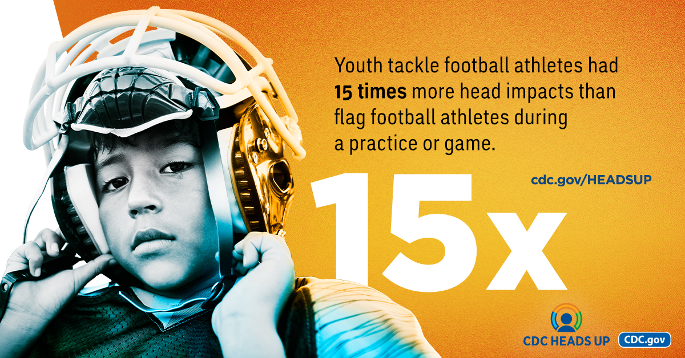

**Key findings from the study** “[Head impact exposures among youth tackle and flag American football athletesexternal icon](https://doi.org/10.1177/1941738121992324)” include:

* Youth tackle football athletes experienced a median of 378 head impacts per athlete during the season.
* Flag football athletes experienced a median of 8 eight head impacts per athlete during the season.

These findings suggest that non-contact or flag football programs may be a safer alternative for reducing head impacts and concussion risk for youth football athletes under age 14.

## More Efforts Needed to Prevent Head Impacts During Youth Football Games

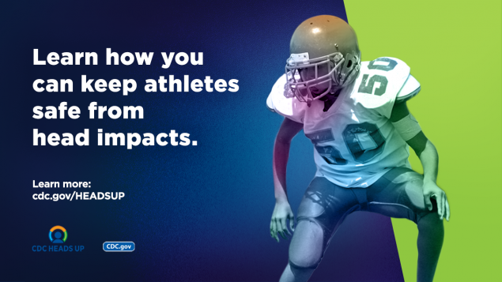

A [second CDC studyexternal icon](https://doi.org/10.1177/03635465211011754) published in The American Journal of Sports Medicine reports youth tackle and flag football athletes sustained two times more head impacts during a game than during a practice.

**Key findings from the study** “[Differences in head impact exposures between youth tackle and flag football games and practices: Potential implications for prevention strategiesexternal icon](https://doi.org/10.1177/03635465211011754)” include:

* Youth tackle football athletes had an estimated 18 times more head impacts per practice and 19 times more head impacts per game than flag football athletes.
* Youth tackle football athletes had an average rate of almost 7 head impacts during a practice and 13 impacts during a game, resulting in 2 times more ≥10g head impacts in games versus practices (g is a measurement of gravitational force equivalent).
* Youth flag football athletes had an average rate of 0.4 head impacts during a practice and 0.8 impacts during a game, resulting in 2 times more ≥10g head impacts in games versus practices.
* Youth tackle football athletes sustained 2 times more high magnitude head impacts (≥40g) in games vs practices.

These findings suggest a greater focus on game-based interventions, such as fair play interventions and strict officiating. In addition, the expansion of non-contact or flag football programs may be beneficial to reduce head impact exposures—especially for youth football athletes.

## We All Play a Role in Protecting Youth from Concussion

**Parents** can:

* Looks for non-contact sports options, such as flag and touch football.
* Read about [concussion safety](https://www.cdc.gov/headsup/basics/index.html) and talk to their child about concussion.
* Make sure their child’s sports team has a concussion safety policy.
* Choose a sports program that enforces rules for safety and avoids drills and plays that increase the risk for head impacts.

**Coaches** can:

* Talk to their athletes about concussion and teach ways to lower the chance for getting hits to the head.
* Avoid drills and plays that increase the risk for head impacts.
* Get informed about school or league concussion policies.
* [Take a training on concussion](https://www.cdc.gov/headsup/youthsports/training/index.html).

**Healthcare providers** can:

* Identify athletes at greater risk for concussion during preseason exams and discuss non-contact sports options.
* Talk to athletes about concussion safety and strategies to lower the chance for this injury.
* [Take a training on concussion](https://www.cdc.gov/headsup/providers/training/index.html).

**Schools and sports programs**can:

* Offer non-contact sports options, such as flag and touch football.
* Make an effort to have certified athletic trainers available at games and practices.
* Enforce rules for fair play, safety, and sportsmanship.
* Inform coaches and parents about school or league concussion policies and offer [trainings](https://www.cdc.gov/headsup/resources/training.html).